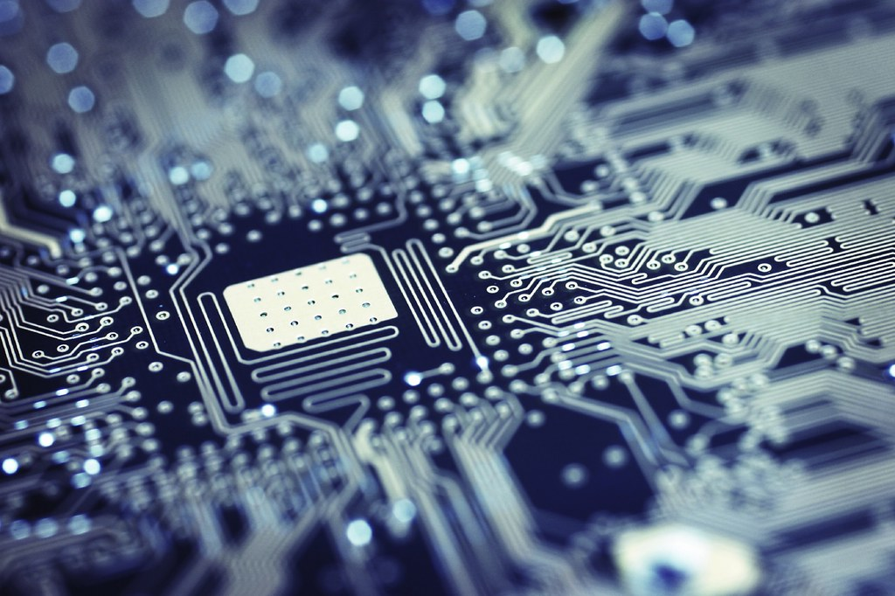

This Photo by Unknown Author is licensed under CC BY


REPORT TITLE

2018

COMPUTER SCIENCE PROJECT
GYAN BHARATI SCHOOL

ACADEMIC YEAR: 2022-23
CLASS : XII
NAME: RIDDHIMA SEN
ROLL NO.: 21
TOPIC: Student Database Management
November 30

COMPANY NAME
Authored by: Your Name

1.1 CERTIFICATE

This is to certify that RIDDHIMA SEN of class 12th has successfully completed the project of Computer science, titled as ‘STUDENT DATABASE MANAGEMENT’, for class XII practical examination of the Central Board of Secondary Education for the year 2022-23.

Teacher’s Signature

  - AcknowledgeMEnt

I would like to express my special thanks of gratitude to my teacher
(Mrs. Neha Gaur Sharma) who gave me the golden opportunity to do this project on the topic: Student Database Management. While completing this project, I researched and studied the coding language deeply, which involved many new concepts. This was a great learning experience.
Secondly, I would also like to thank my parents who guided me and advised me to finalize this project within the limited time frame.

- Riddhima Sen

INDEX

S.No
PAGE NO.
TOPIC

1.
1.
COVER PAGE

2.
2.
CERTIFICATE

3.
3.
ACKNOWLEDGEMENT

ABSTRACT AND DESCRIPTION
5. - 6.
4.

HARDWARE REQUIREMENTS
5.
7.

8.
6.
TOOLS REQUIRED

9.
TABLES
7.

10. - 11.
8.
SOURCE CODE

12. - 15.
9.
OUTPUT

16.
10.
FUTURE SCOPE

17.
11.
BIBLIOGRAPHY

1.3 ABSTRACT

The objective of this project is to analyze and modify a student database using python language. This project will therefore help teachers, examine the performance of a student by reducing manual work. This project will be beneficial in following ways:
- Both the student and the teacher can work on this interface. The features provided to the student and teachers are different.
For Student:
- Only new entry of the student is possible
For teacher:
- Insert student data
- Update student table info
- Arrange alphabetically(asc/desc)
- Delete the complete data
- Exit
The following software are used for completion of this project:
- Python- Spyder
- MySql
This project will act instrumental for effortless analysis of excessively large databases which cannot be achieved without computerization. Also, I would like to add that this project could have more parameters, however due to time constraint and less knowledge in this area, I have highlighted the main 5 topics that a user would want to search.

1.4 Description
In this project, I have first written a code for data creation in Sql. The name of the database is project, the table name is student. the picture attached below (Fig1. Is the dummy data which has been created in MySQL).
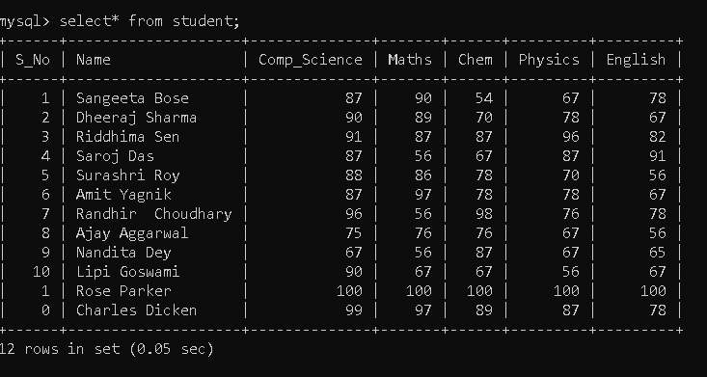
Fig 1.
The parameters of this table are;
- Name of the student
- Marks in Computer Science
- Marks in Mathematics
- Marks in Chemistry
- Marks in Physics
- Marks in English
The following options have been provided to the teacher: (refer to figure 2)
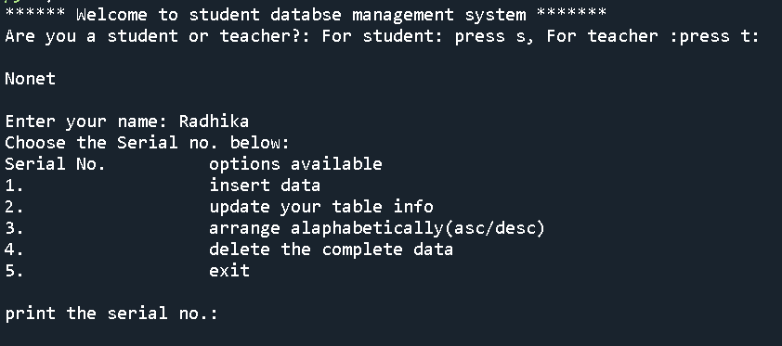

1.5 Hardware requirements
Component | Requirement
Hard Disk | SQL Server requires a minimum of 6 GB of available hard-disk space.  Disk space requirements will vary with the SQL Server components you install. For more information, see Hard Disk Space Requirements later in this article. For information on supported storage types for data files, see Storage Types for Data Files.
Monitor | SQL Server requires Super-VGA (800x600) or higher resolution monitor.
Internet | Internet functionality requires Internet access (fees may apply).
Memory * | Minimum:  Express Editions: 512 MB  All other editions: 1 GB  Recommended:  Express Editions: 1 GB  All other editions: At least 4 GB and should be increased as database size increases to ensure optimal performance.
Processor Speed | Minimum: x64 Processor: 1.4 GHz  Recommended: 2.0 GHz or faster
Processor Type | x64 Processor: AMD Opteron, AMD Athlon 64, Intel Xeon with Intel EM64T support, Intel Pentium IV with EM64T support
The following memory and processor requirements apply to all editions of sql.

1.6 Tools Required
- Mysql
- Python- spyder


1.7 Table
Table name- student
The parameters of this table are;
- Name of the student
- Marks in Computer Science
- Marks in Mathematics
- Marks in Chemistry
- Marks in Physics
- Marks in English
Code for creation of the table:
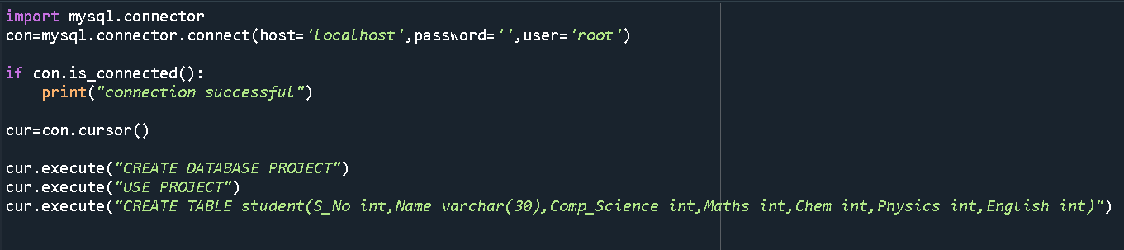
Fig 3.

1.8 SOURCE CODE
- Creation Of Database:
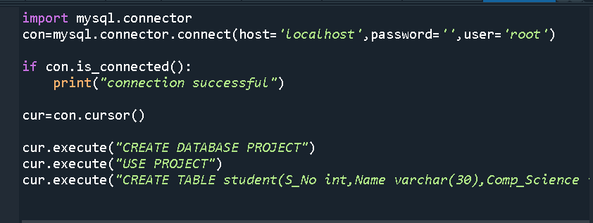
- Program code for project- for a Teacher
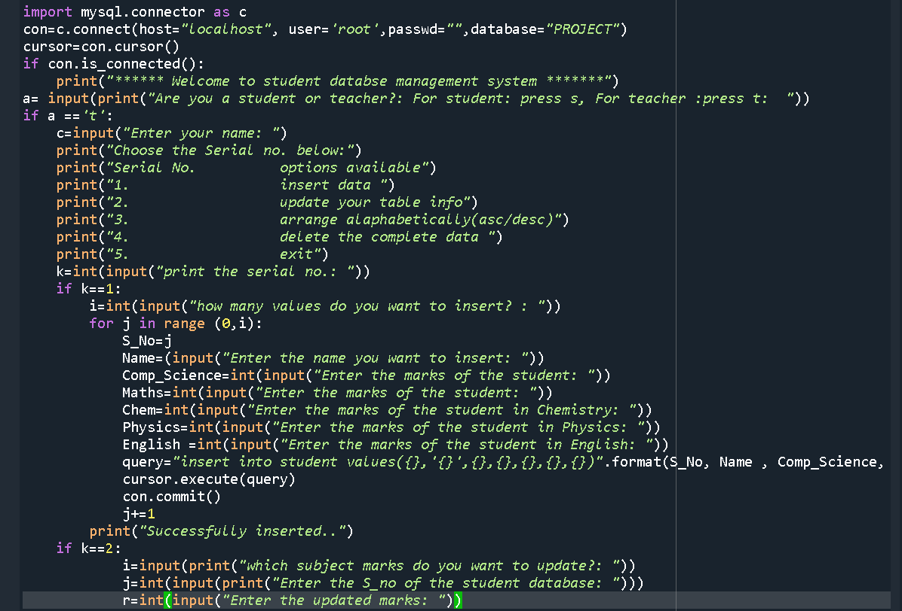

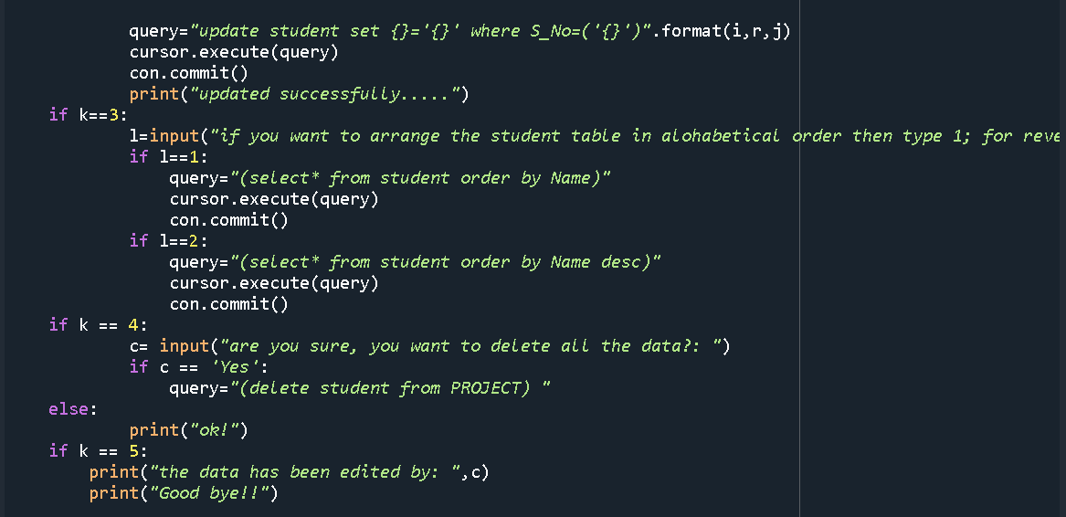

- Program code for project- for a student
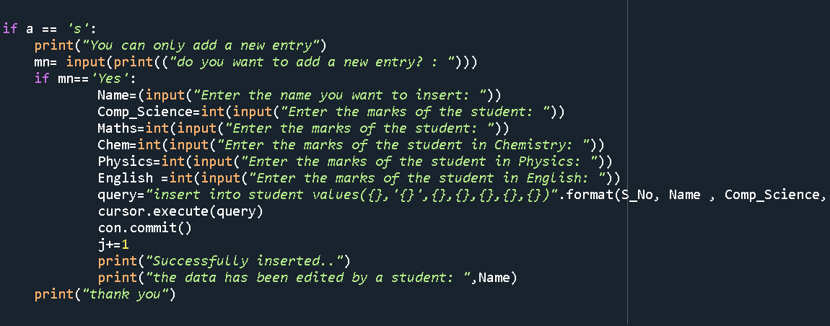

1.9 Output

Output for successful connection:
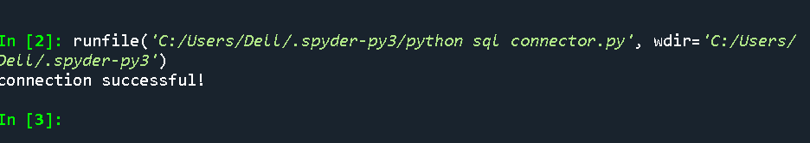
Teacher:
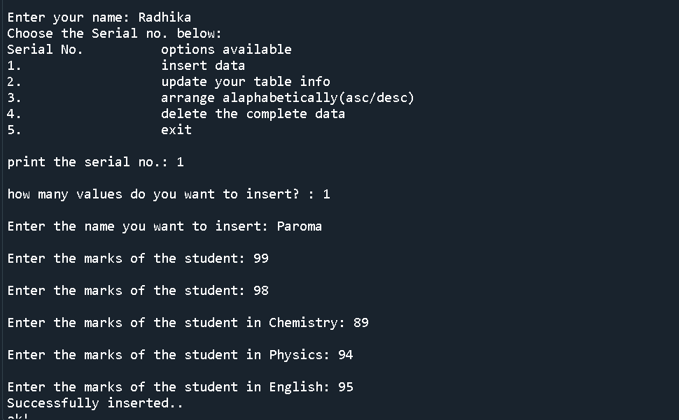
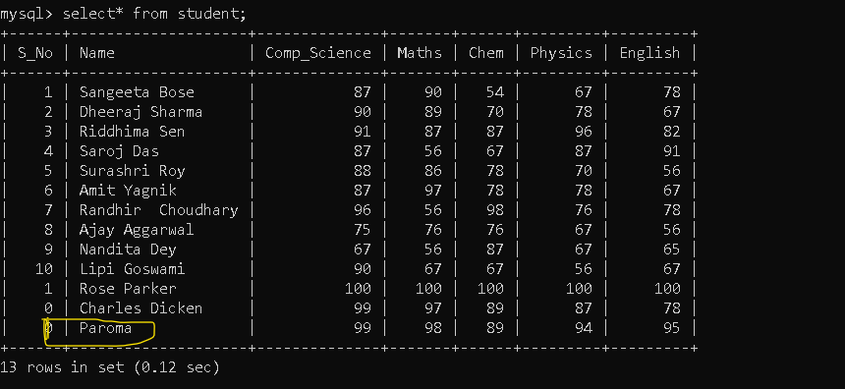
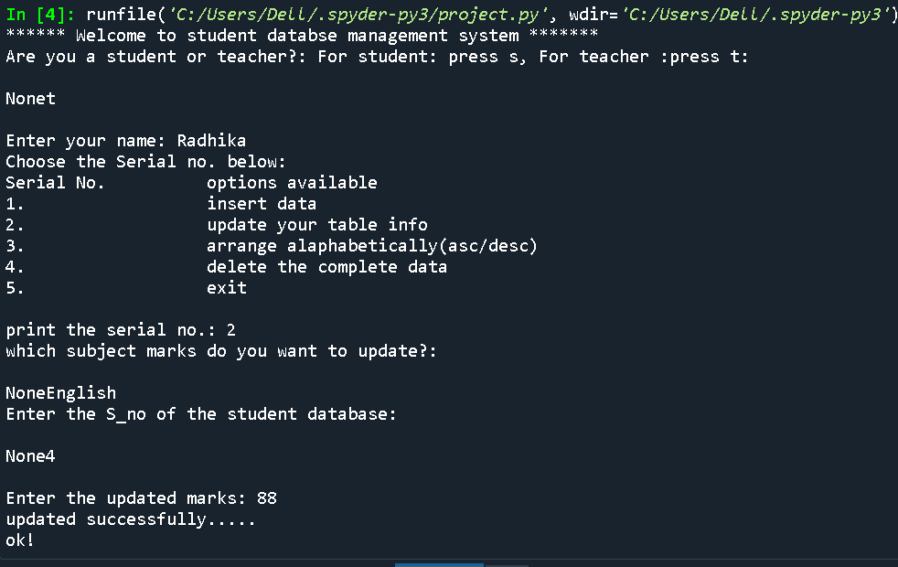
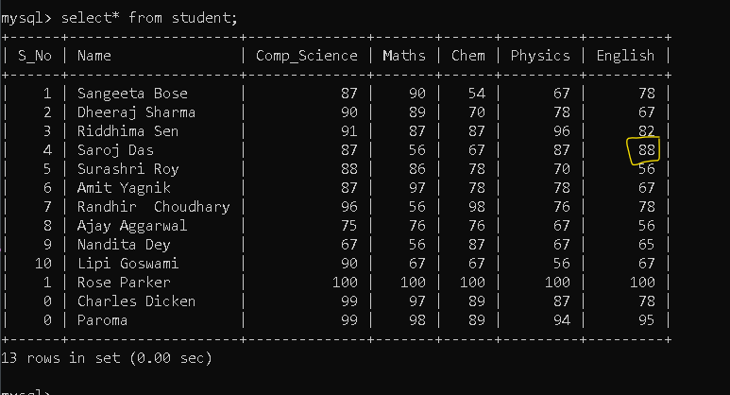

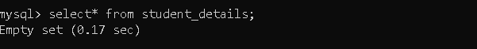

- Student:
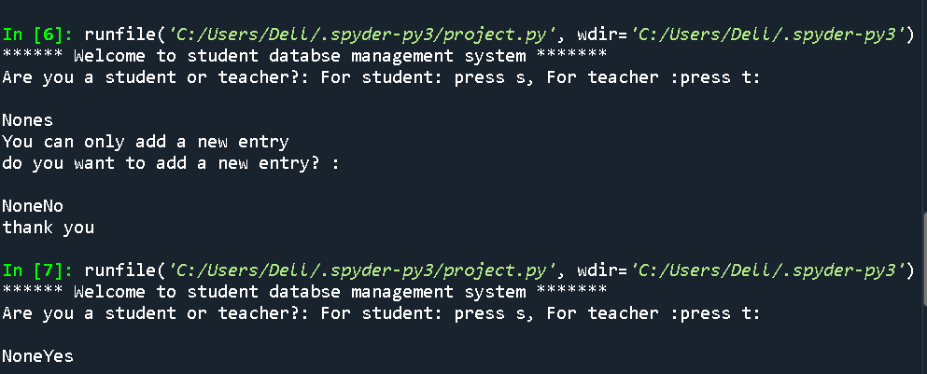
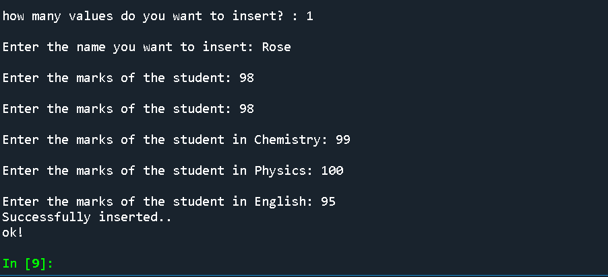
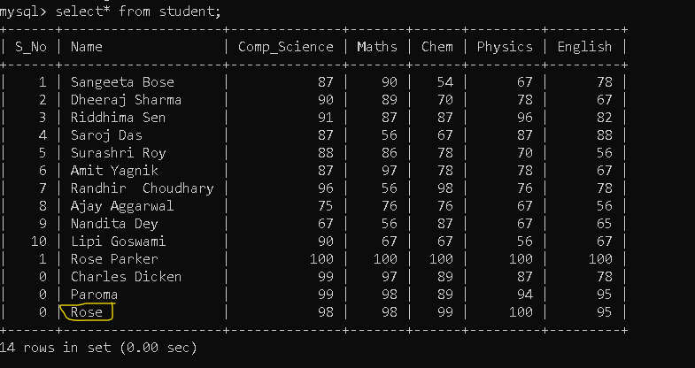

1.10 FUTURE SCOPE

This project will act instrumental for effortless analysis of excessively large databases which cannot be achieved without computerization. Also, I would like to add that this project could have more parameters, however due to time constraint and less knowledge on this area I have highlighted the main 5 topics that a user would want to search. For the program to be more effective, I have even created two modes of data analysis. One is the teacher mode and the other is the student mode. A teacher and a student can independently work upon the data. After the changes, the name of the person who has updated the data will also be verified. Further, this project can be developed to make student data analysis an easier job for teachers and students.

1.11 BIBLIOGRAPHY

- https://www.youtube.com/watch?v=323H_mOOWQ4&list=PLxCzCOWd7aiHqU4HKL7-SITyuSIcD93id

- https://www.tutorialspoint.com › sql

- https://www.learnpython.org/
- https://www.python.org/

- https://www.w3schools.com › sql

